Question 1:

- 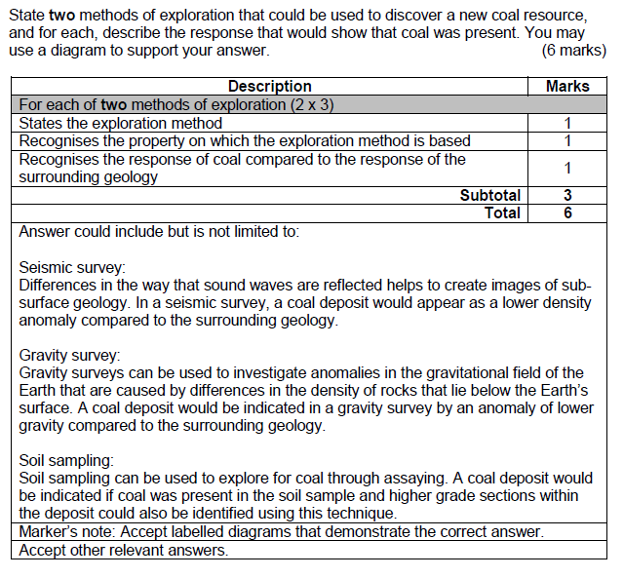
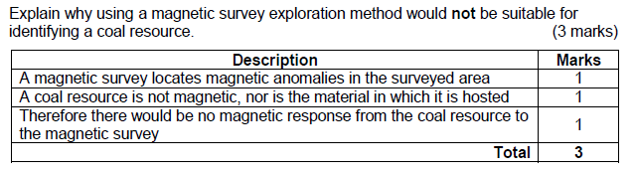
Questions 2. Surface mining (4 marks)
- Involves the removal of plant life and topsoil in order to access shallow deposits as cheaply as possible.
- The resource needs to be close to the surface
- Resource deposit does not need to be a high grade
- Hole dug down in stages to make benches, this adds stability and multiple places to excavate

Question 3. Underground mining (4 marks)
- When deep underground, vertical shafts are dug in order to reach the resource deposit
- This can also be done when the resource is found in pockets rather than a single deposit
- Internal ramps can then be dug out in order to access different levels.
- More costly than surface mining, but there is less surface environmental impact
Question 4.
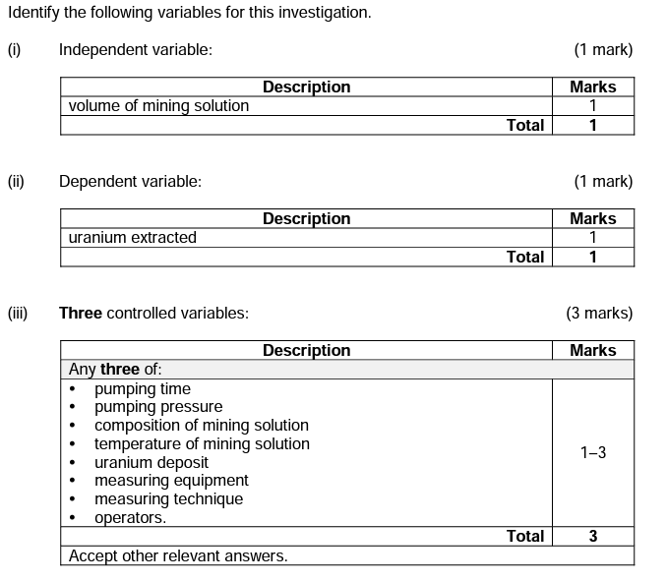
Question 5.
